SIM ™ CER PD Action Plan

During the 2020-2021 school year we plan to use my SIM™ CER professional developer certification to provide Training and Technical Assistance to the schools T/TAC W&M supports in VA Superintendent’s regions 2 and 3.
We have developed virtual hybrid synchronous professional learning with online coaching opportunities for our teachers (see agendas below). This year the Unit Organizer sessions will be conducted live, through virtual meetings on June 16th, July 15th, and October 14th. The Vocabulary LINCing session will be conducted using the same format, on January 13th, February 17th, and March 10th. Both Sessions will have an embedded coaching component ongoing prior to, in between, and after sessions.
We have also developed an asynchronous, self-paced, learning opportunity for The Unit Organizer Routine in case we have additional interest from teachers. This module has a coaching component to provide support towards planning and implementation. (See the requirement checklist below). The embedded coaching component will be ongoing during the self-paced course. We will develop a self-paced companion module in 2021 for Vocabulary LINCing CER.

Strategic Instruction Model (SIM ) Unit Organizer (UO)–Content Enhancement Routine (CER)
Session 1 Agenda-June 16, 2020
Zoom meeting 10:30-12:00 p.m.
Creating Community
- Please use gestures, reaction button or chat to ask questions or signal you’d like to speak.
- Keep microphones on mute when in the large group and not speaking.
- Assume positive intent o group members.

- Introductions:
  - Each participant will share their name,
  - what and where they teach and
  - one word that captures what they love best about teaching.

- Small group activity 1:
  - Select a facilitator, encourager, recorder / reporter (to report to the large group)
    - Share impressions of UO lessons 1 and 2 videos and be prepared to report
      - what questions you have from the part 1 and 2 video lessons.
    - Discuss and report
      - what was the most effective thing(s) you saw in the example video.
    - Discuss and report ideas on
      - how you plan to implement UO within your classroom.

- Small group activity 2:
  - Select a facilitator, encourager, recorder (to type in chat) , and a reporter (to report to the large group)
    - Discuss and identify unit relationships for our course (step 6 on UO) and develop self-test questions (step 7). Answers within the group may vary. You may refer to Blooms Taxonomy (below) to identify unit relationships.
    - Report at least
      - one question and one unit relationship to the large group.

- Wrap up:
  - Lingering questions addressed.
  - Review assignments to be completed prior to our next session on July 15th.

SIM UO Session 2
July 15th, 2020 Agenda
- Welcome: Please share an educator/author whose work has positively influenced your teaching practice.

- Q & A: What questions do you have after developing your draft Unit Organizer?

- Small group collaboration: Have one participant at a time share screen with their draft UO. Using the device checklist (attached to email /printed or downloaded to your computer or on your phone /found at link below/or snap a photo with your phone from the slides during the session), talk through the components of the draft that is present and brainstorm ways to include parts that are not yet present.

- Click here to find pre-work for session 2 and the draft checklist you will need for this activity.
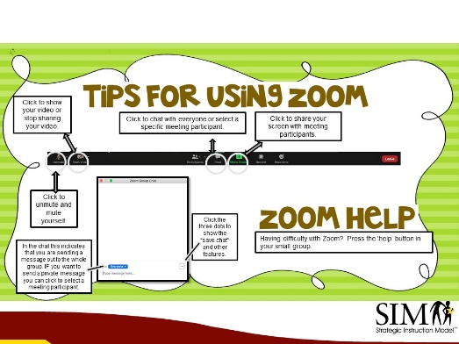

- Large group share:
  - What revisions did you make to your draft?
  - What were your insights after giving and receiving feedback on your draft?
  - Are you ready to implement with your class?
- Preparing for our next session: Please video record (Using your phone or computer) your lesson(s) using your draft UO. By October 1- Email your video to Shelley and Donni. Use the implementation checklist found on our website to reflect on your video.
  - Contact us if you would like thinking partners to plan for your lessons and/or feedback on your lessons.
  - Review information on micro credential (optional)

- Provide Feedback:
Please provide us with feedback on session 2 by clicking the link below or scanning the
QR code.

https://www.data.ttac.vt.edu/ttac/eval/?9533

Self-Paced SIM™ Unit Organizer Course Checklist with coaching support

Task | Date Completed
On the website tab:
Pre-Work 1: Assignments Due Prior to First Session

- Watch course introduction video
- Review SIM Unit Organizer book mark in course expectations
- Watch SIM Unit Organizer lesson videos 1 + 2
- Watch SIM Unit Organizer example video
On the website tab:
Session 1 Presentation and Recording

- Watch recording of session 1

On the website tab:
Pre-Work 2:Assignments Due Prior to Second Session

- Develop a draft Unit Organizer (UO) for a unit you would like to teach in the early fall.
- Email us your draft Unit Organizer. If you want feedback or support in developing a draft UO let us know and we can meet virtually to discuss.
- Watch video example of teacher using the UO routine.
On the website tab:
Session 2 Presentation and Recording

- Watch the recording of session 2 on the website.
On the website tab:
Pre-work 3: Assignments Due Prior to Third Session

- Review the process for teaching your unit using the UO from your draft, record your instruction and submit it to us by October 1st.
- Our next zoom class is October 14th at 4:00-5:30.
We are happy to assist you so please reach out when your UO draft is developed.

