Shelby Kelchen
The Inference Strategy
Portfolio of Implementation

1)Describe the group or student (size of group, level, student characteristics, etc.)
2019-2020 School Year
I am teaching The Inference Strategy to a group of middle school students. My group consists of 4 students in sixth grade. All four students are entitled for special education services and have reading comprehension goals. One of the students is also entitled for writing and two of the students have math goals. There are three girls and one boy in my group.
These students are also in a co-taught language arts class with me for 110 minutes each day. This time is spent working towards becoming proficient at grade level standards.

2020-2021 School Year

I am teaching The Inference Strategy to two groups of middle school students in 7th grade. My first group is a virtual group. This group consists of 4 students. All four students are entitled for special education services and have reading comprehension goals. One of the students is also entitled for writing. Two of the students have math goals. There are two boys and two girls in my group.
My second group consists of three girls. They all have reading comprehension goals. One has a writing goal and the other two have math goals. In addition, one student is entitled for behavior. These students are also in a co-taught language arts class with me. This time is spent working towards becoming proficient at grade level standards.

2) Describe the length of implementation (weeks or months, amount of time per day, days per week)
2019-2020 School Year
I meet with the students one time a week for 50 minutes. Students are pulled out of either science or social studies for these 50 minutes. I began teaching the Inference Strategy in October 2019. We were unable to complete the strategy this school year due to Covid.

2020-2021 School Year

Virtual Students: I meet with these students 2 times a week for 20 minutes.
Hybrid Students: I meet with these students 2-3 times per week (Tuesday, Thursday, and every other Friday) for 25 minutes.
3) Submit student progress chart(s) without student names.
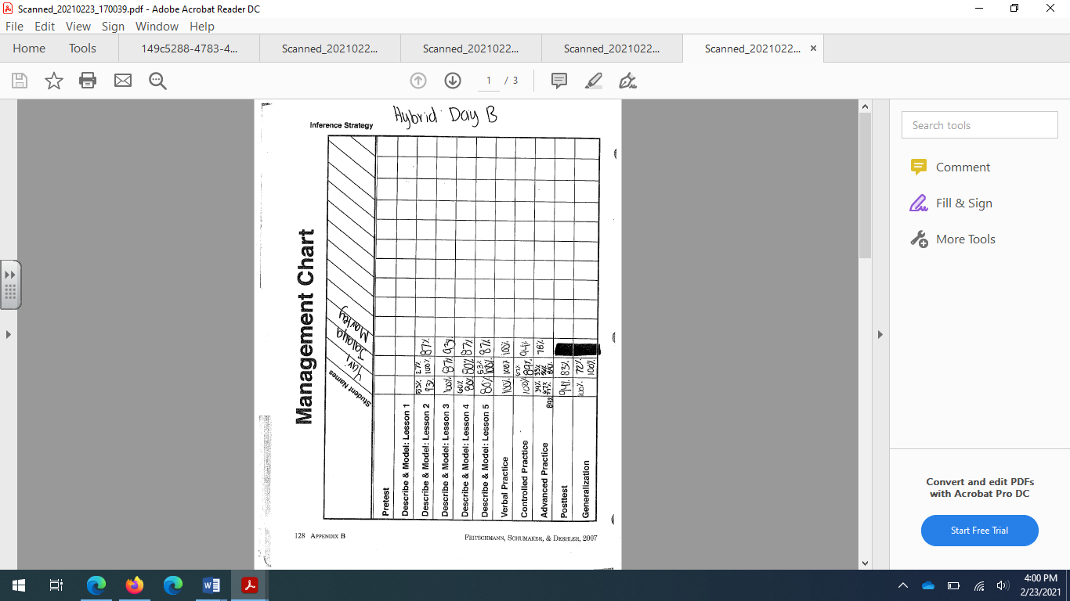
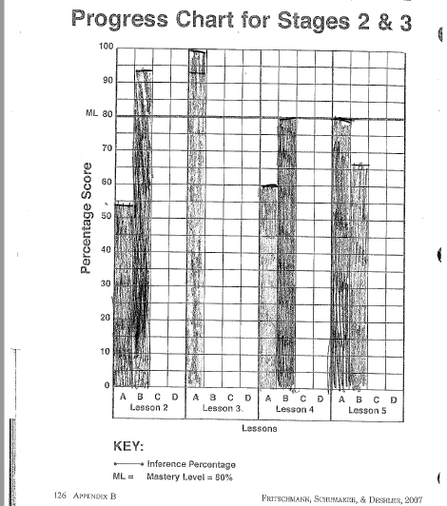
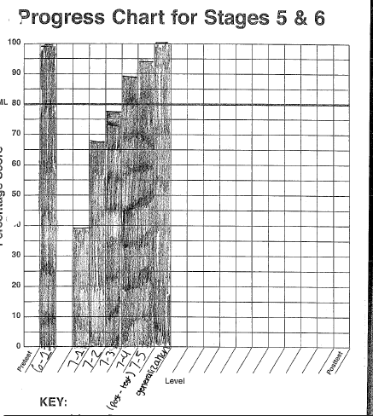
4) Submit a narrative log of your implementation experiences (what went well and/or poorly, adjustments made if necessary, ideas generated for issues encountered, and impact.)
I began teaching The Inference Strategy in October 2019. The first 3 months of teaching this strategy were a struggle. The main challenge was not having adequate time to teach the strategy the way it is supposed to be taught. Students were forgetting what was taught in previous lessons so I would have to spend a lot of time reteaching. Furthermore, it has also been a challenge dealing with students being absent. One of the students in my group has missed 116 total class periods (as of March 2nd) and has been tardy 153 times.

3/2/20
Towards the end of February I tried a different approach. Rather than re-teaching the lessons word for word as they are in the manual, I decided to focus on what the students were really struggling with. It was clear from the lesson 3 independent practice, students were struggling to differentiate Factual Questions and Big Picture Questions. We spent 2 class periods really zoning in on the difference between these types of questions. Students made flash cards, practiced sorting questions, and played a Kahoot game. Students were then assessed using Lesson 3, Passage 3. This time, all students reached mastery.

9/28/20
Due to Covid, there was an extended school closure for the spring of 2020. Therefore, I was unable to complete the Inference Strategy with my students. However, I looped with my students. My students did not retain much of the strategy and new students were added to my groups, so I decided to restart the strategy. I am currently teaching a virtual group and hybrid group. The virtual group is moving much slower than my hybrid group. My hybrid group is currently stuck on Big Picture Questions. We are taking time to work on the key terms associated with Big Picture Questions.

10/15/20
All of the students in my hybrid group have officially passed the Big Picture lesson. I feel like they finally have an understanding of the key terms associated with Big Picture Questions. My fully virtual group has continued to be a challenge. The main challenge I am experiencing is students missing zoom sessions. I have been making videos of the lessons and posting them on our Canvas page. Students are supposed to watch the lesson when they miss a zoom session and complete an exit ticket.

12/7/20
My hybrid learning group are now at Stage 5 (Controlled Practice and Feedback). They did really well with the verbal quiz. All of the students demonstrated they understand the steps of the INFER strategy and the purpose of the Inference Strategy. Today was the first time in over 3 weeks that I have seen students in person. I spent two weeks quarenting due to a positive Covid exposure. Last week the whole district participated in fully remote learning. This has slowed down my group a bit. We were not able to cover as much during these weeks. However, I still taught at home while I was quarantined. I zoomed with my students while they were at school and we started the control practice. We did a passage together as a group and then the students worked on one together while I observed. Tomorrow they are going to attempt an independent practice passage.

12/15/20
Today I began the advanced practice. Students seem to be doing well with the Inference Strategy. All students passed the controlled practice. I ran out of passages for one student during the controlled practice. We did one passage together, one with a partner, and then an independent attempt. After all of that, there was only one passage left that was about a girl getting drunk at a frat party. Rather than using that passage, a passage that was similar in length and complexity. I created questions for the passage that were modeled after the questions from the other passage.

1/28/21

My biggest challenge right now is absenteeism. One of my hybrid students has missed several days of school. This is especially challenging since we are on the hybrid schedule. When she misses one day of school, it might mean that I won’t see her for a week. There was also a snow day this week. This meant I didn’t see my hybrid mean students for a whole week. The two students in my hybrid group are now at different points in the Inference Strategy. One student completed the generalization piece today. The other student is on the advanced practice. One thing that is going well is the entrance ticket I’ve been trying with my students. When they come to class I give them a couple sticky notes. Each sticky note has a question written on it. They then write what type of question it is on the back. Then before we begin class, they share their question, what they coded it, and why they coded it that way. This seems to be engaging for the kids.

2/23/21

My students recently completed the Inference Strategy. As mentioned in my January reflection, absenteeism has been a major challenge for one of my students. Therefore, the two students in my group finished out the strategy individually. I could not hold one student back each time the other student was absent. I found that I was able to get through the material faster and they understood the strategy better when I taught it one-on-one. My students seem to understand the strategy and are able to generalize the strategy into the reading for their other classes.
5) Submit a narrative describing coaching, feedback, and follow up, identifying your coach.
2019-2020 School Year
Date | Description
2/11/20 | Zoom to discuss micro credentialing process and our progress on teaching the strategy.
2/24/20 | Zoom to discuss progress
3/2/20 | Emailed with coach to ask questions
3/30/20 | Zoom to discuss videos

2020-2021 School Year
Date | Description
9/28/20 | Zoom to discuss plan for this school year and finishing the micro credentialing process.
12/9/20 | Zoomed to discuss video. Talked about the describe part of the lesson and ways to improve that section.  Went over progress on badge and next steps.
1/13/21 | Zoomed to discuss feedback on video. Mark went over the checklist and what I still need to do.
3/1/21 | Zoomed with Mark. Went over process of instruct a teacher.
3/30/21 | Zoomed with Mark. We discussed what I need to finish to complete my badge. We discussed a timeline for completing these items.

