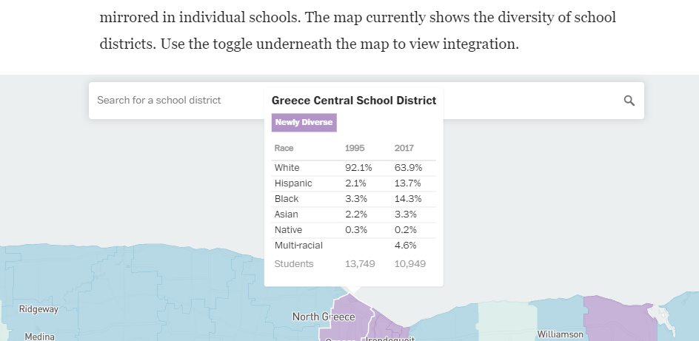
I selected Option 3. I read The Washington Post article and used the school diversity data tool. Everyone should look at this. I was able to see my school district and could see how we are newly diverse and highly integrated. I heard this information before but now I have the data to back it up. Great tool. I hope they update the tool to 2021. Thank you for including this.

