Lauren Osterhaus
The Inference Strategy
Portfolio of Implementation
Describe the group or student (size of group, level, student characteristics, etc.)
I am teaching this strategy to three seventh grade students. One student is a virtual learner this school year, and the other two students are participating in hybrid learning. All three students have IEP’s with reading services. They have IEP goals measuring reading comprehension using probes that require them to read a passage and accurately answer multiple-choice questions about the passage (one student at the 6th grade level, and the other two students at the 7th grade level). Their reading skills are below - but approaching - grade level, and I am using this strategy to help them learn to make inferences while reading and apply this strategy both on assessments and in their general education classes.

Describe the length of implementation (weeks or months, amount of time per day, days per week)
I work with the two students who are participating in hybrid learning on the days that they are at school in person (Mondays, Wednesdays, and every other Friday) for 25 minutes per session. I implemented this strategy with them from September 2020 through February 2021.
I work with the student who is participating in virtual learning twice a week for 30 minutes per session. I implemented this strategy with him from September 2020 through April 2021.

Submit a narrative log of your implementation experiences (what went well and/or poorly, adjustments made if necessary, ideas generated for issues encountered, and impact.)
September 2020 – I started implementing the Inference Strategy with a group of two students who are enrolled in hybrid learning, and one student who is enrolled in virtual learning. Our sessions are only 25-30 minutes long, which makes it difficult to get through a whole lesson. I started with administering the pre-test. I have been breaking apart the other lessons into chunks. I usually get through the “Introduce and Describe” in one session, the “Demonstration Activity” in another, and the “Independent Practice Activity” in the next. At the beginning of each session, we spend a few minutes reviewing what we learned last time to help refresh the students’ memories.
October 2020 – With the hybrid schedule, it has been difficult to maintain the continuity of our lessons since I don’t see the students every day. Now that we have gotten into Big Picture questions and Predicting questions, students are having a hard time remembering the key words and what each one means. We’re taking some extra time to focus on and practice these key words and identify types of questions before students do their independent practice. I’ve also found that teaching this strategy virtually, over Zoom, takes longer and is more challenging since I cannot model and work through passages with the student right in front of me. I’ve tried this a couple of ways – sharing my screen with the student and using a digital copy of the passage to model the strategy; and also using a document camera to model marking a paper copy of the passage. So far it seems that the paper copies are easier for the student to use, although I am unable to see the student’s work unless they take a picture of their completed passage and send it to me.
November 2020 – One of my hybrid students has been absent from school more and more frequently. When he is absent, I have been working on reviewing and generalizing with my other hybrid student, instead of moving on to the next part of the lesson without him. I want to keep both students in this group working at the same pace, because I don’t have extra time in the school day to teach them separately. We’ve been using anchor charts for each question type, and I created a reference sheet for both my in-person and virtual students to use to keep track of the question types and key words.
December 2020 – This month I created flashcards with examples of different types of questions for my students to use as practice. I think it is working well to help them notice the differences between each type. They are still having a hard time generalizing these to their independent practice. I’ve noticed that nonfiction passages seem to be more challenging for them than fiction, perhaps because of the vocabulary and background knowledge needed to comprehend them. My virtual student has been missing their Zoom sessions with me this month, and I have not been able to make contact with them yet.
January 2021 – My in-person students are struggling to differentiate between big picture and clarifying questions, so that has been a focus of my instruction lately. I’ve also been starting each lesson asking the students to write down the Inference Strategy steps on whiteboards, as well as the question types. This seems to be improving their memory. Still no contact with my virtual student. I’m working with other staff members at school to try to reach him. Once we get our Zoom sessions set up again, I’ll need to spend time with him reviewing what we have already learned with the Inference Strategy before we can proceed with the next lessons.
February 2021 – One of my students has showed great success with using the Inference Strategy for reading comprehension. She has been able to apply it while reading texts in other classes, such as social studies and language arts. She has met her IEP goal in reading comprehension and will be exited from services in this area. The Inference Strategy has contributed to her progress this school year. I’ve resumed my lessons with my virtual student, which is going smoothly. They are making quick progress and I am anticipating we will finish the strategy before the end of the school year.

Submit student progress chart(s) without student names.
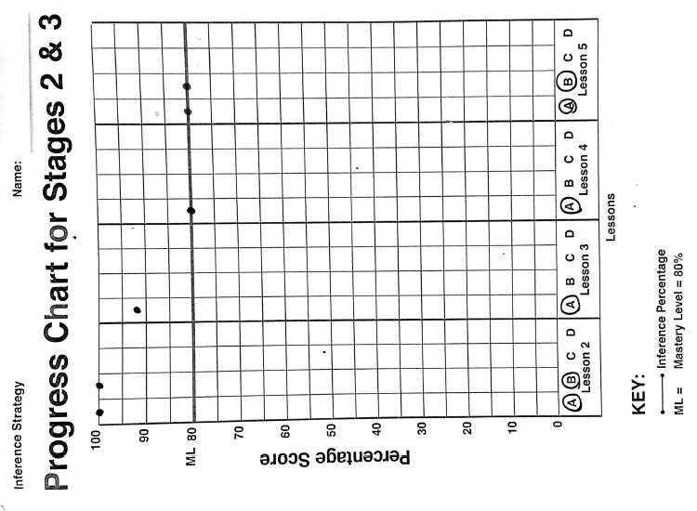
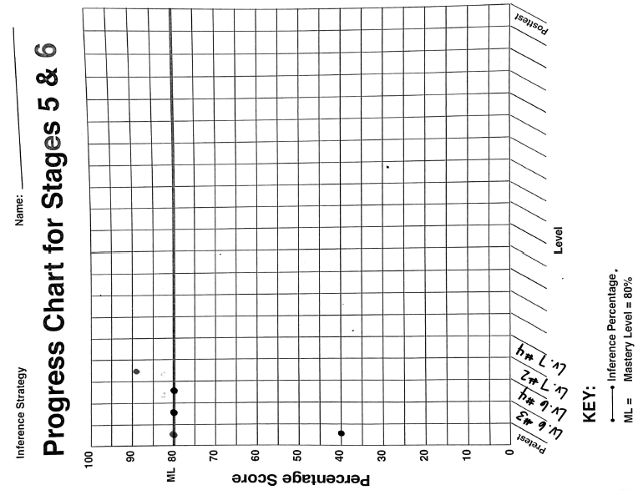

Submit a narrative describing coaching, feedback, and follow up, identifying your coach.
Mark Burnett is my coach for my KU micro-credential. We met via Zoom about once per month during the 2020-2021 school year. I shared my recorded lesson videos with him, and he gave me constructive feedback for my lessons as I was teaching them. He was especially helpful with advice for teaching the Inference Strategy to my students who were participating in online learning. After viewing my recorded lessons, we met via Zoom to discuss how it went and so Mark could share feedback with me. He emphasized the importance of using the appropriate terminology for each step of the lesson – “Describe”, “Model/Demonstrate”, etc.

